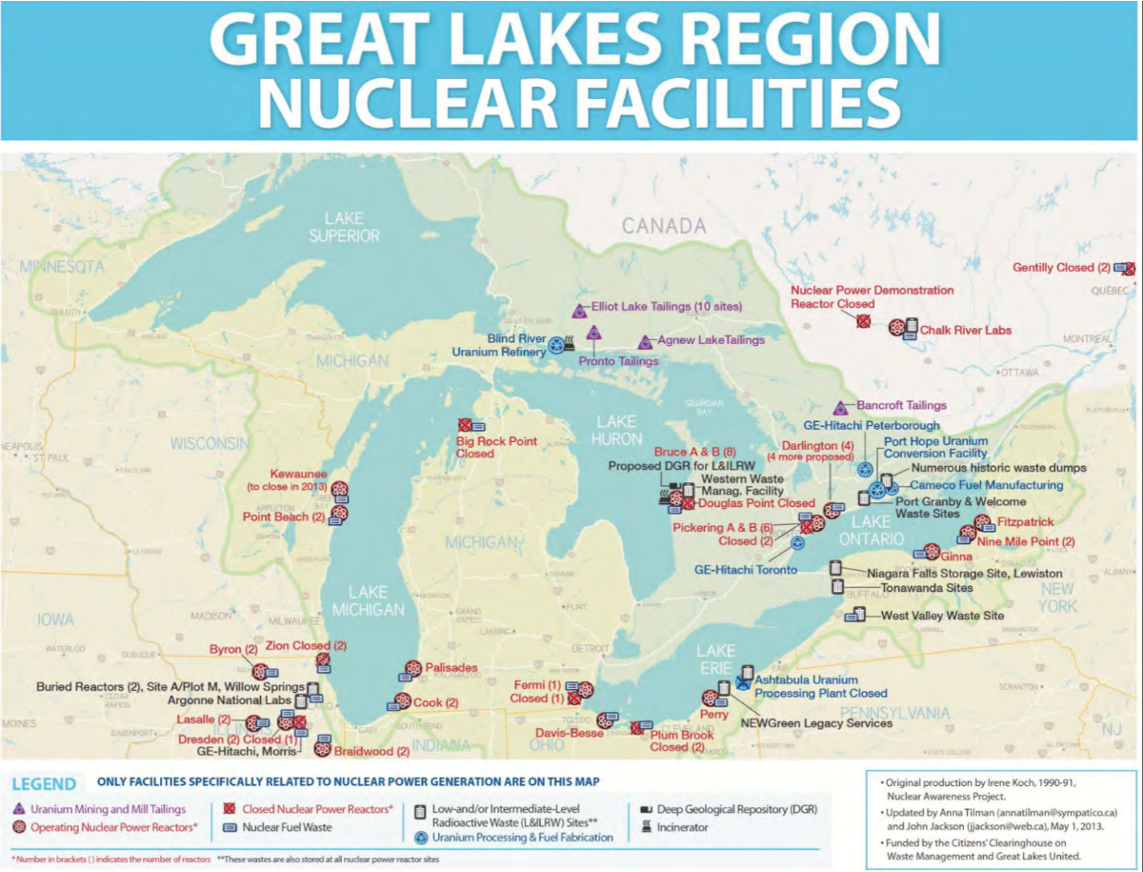
In addition to 18 nuclear power plants in the basin, this map shows other facilities involved in the nuclear energy lifecycle in and around the Great Lakes basin. Credit: Citizens’ Clearinghouse on Waste Management and Great Lakes United

For New York and Canadian Lake Ontario, the seven nuclear power plants are:
*Nine Mile Point 1, Nine Mile Point 2, James A Fitzpatrick, Robert Emmett Ginna, in New York; Pickering, Bruce, and Darlington in Ontario.

There is also one nuke plant on Long Island Sound at East Shoreham. And, of course, Indian Point closed, but with its payload of radioactive waste still stored onsite along the western Hudson River shoreline, awaiting safe disposal.”

