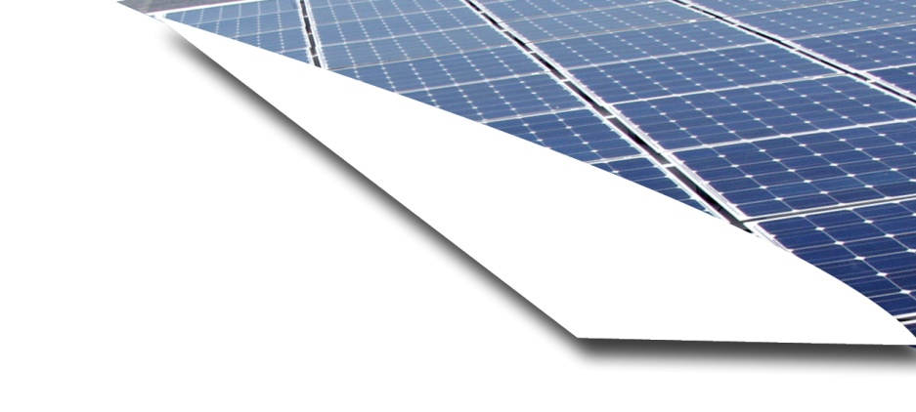

**Getting neighbors together makes solar power easier to install   
and more affordable than ever.**

How to Get Started

* Attend a community meeting in your town or any town that is convenient for you to learn more.
* Enroll in the program at that meeting or at [website].
* Get a site assessment and a solar installation price quote from a Selected Installer(s).
* Sign a contract to have your new solar electric.
* Get your neighbors to join.
* Start producing clean electricity and save on your energy costs for years to come.

Solar energy can do good things for your community. Solar power is clean energy that does not give off greenhouse gas emissions and protects the environment. Converting sunlight to electricity right at your home can save you and your neighbors money on utility bills and reduce your community’s reliance on fossil fuels.

Why Solarize?  
Solarize [municipality] is a grassroots initiative that helps communities get a group rate for installing residential solar electric systems. The group rate is more affordable than doing it on your own. Solarize program discounts on solar electric systems increase as more people sign up. A pre-selected, competitively chosen contractor for [name of area] installs the systems.

Solarize [municipality] helps local groups across New York State install solar and save thousands of dollars by working together. We are inspired by successful solarize programs across the United States, including groups in Massachusetts, Connecticut, and Oregon. Our goal is to double the total amount of residential and small business solar electric installed to date, and to permanently increase the use of solar locally.



**Solarize**

**[insert municipality]**

Meet the neighborhood solar installer

[Name of contractor] is the official Solarize solar installer for [municipality] and has been   
serving [name of the area] for [xx] years, providing residential and commercial solar installations.

To find out if your home or business is right for solar and get a free no-obligation site assessment, contact [contact person’s name] at [name of contractor] at [email] or [phone].

Average purchased system cost for a 7-kilowatt system

|  |  |  |  |
| --- | --- | --- | --- |
|  | Market | Tier 1 | Tier 2 |
| Price* | $xx,xxx | $xx,xxx | $xx,xxx |
| NYSERDA Support* | $xx,xxx | $xx,xxx | $xx,xxx |
| Federal Tax Credit* | $xx,xxx | $xx,xxx | $xx,xxx |
| Your Net Price | $xx,xxx | $xx,xxx | $xx,xxx |

*Because every system varies based on production levels, some solar contractors may have equipment receiving a slightly higher or lower incentive level (for example, microinverters as a standard) which may call for adjustments.

**Learn more**

Visit [website] to learn more about Solarize.

To set up a free, no obligation site consultation, email [address] or call [number].